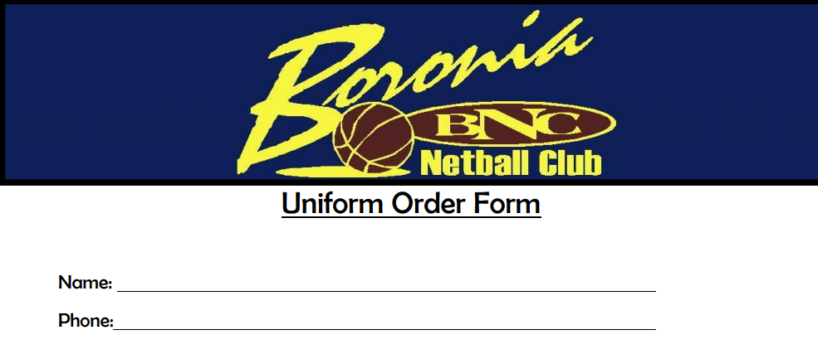
U11 Uniform Only (Please circle required size) QTY TOTAL
Top 8 10 12 14 $30 x ______ = $______
Skirt 8 10 12 14 (loan skirt provided for the season) $0 x ______ = $______
BBC Racer Back Dress (Please circle required size)
XS S M L XL XXL $80 x ______ = $______

BNC Club Jacket (Please circle required size)
XS S M L XL XXL $55 x ______ = $______

BNC Zip UP Hoodie (Please circle required size)
XS S M L XL XXL $50 x ______ = $______

BNC Training Top (Please circle required size)
XS S M L XL XXL $20 x ______ = $______

BNC Rugby Jumper (Please circle required size)
XS S M L XL $90 x ______ = $______
Payment must be made in full prior to collecting order
